Abstract
Machine learning (ML) models increasingly underpin critical business functions, yet organizations still struggle to move models from notebooks to reliable, scalable production services. The operational gap—often called the “last mile” of ML—stems from infrastructure complexity, inconsistent packaging practices, weak versioning, ad-hoc security, and insufficient monitoring. This dissertation presents a cloud-powered model deployment platform designed to make serving ML models fast, reproducible, and cost-effective. The platform abstracts infrastructure details behind a simple, opinionated workflow: data scientists upload a trained artifact with minimal metadata; the platform validates and packages it into a standardized runnable unit; a deployment engine exposes a secure REST endpoint; and observability components track latency, throughput, errors, and model health in real time. By embracing containerization and cloud-native principles, the design supports horizontal scaling, automated rollbacks, and multi-version routing while remaining lightweight enough to run locally for development and teaching.
The work proceeds in two phases. Phase one delivers a local, Flask-based prototype that demonstrates the full lifecycle—model registration, versioning, activation, prediction API, basic authentication, structured logging, and Prometheus-style metrics—on a single machine with SQLite and filesystem storage. This validates the core abstractions without the overhead of continuous integration or cluster orchestration. Phase two outlines a cloud-ready architecture using Docker images, a container registry, and Kubernetes (or managed equivalents) for high availability, autoscaling, and traffic management. Helm-based manifests and infrastructure-as-code enable repeatable deployments, while a lightweight model registry preserves lineage, artifacts, and configuration for each version. The platform further anticipates governance needs through access control, request/response auditing, and configurable retention.
Evaluation focuses on developer experience, operational reliability, and efficiency. Metrics include time-to-first-prediction from artifact upload, p95 latency under concurrent load, error rate during rolling upgrades, and ease of rollback. A demonstration suite deploys multiple models (e.g., scikit-learn, PyTorch, ONNX) with small synthetic inputs to validate framework agnosticism and schema enforcement. The results show that a disciplined packaging and serving path dramatically reduces deployment latency and cognitive load, while built-in monitoring and versioning reduce operational risk. This research contributes a pragmatic middle ground between heavyweight managed MLOps platforms and fragile bespoke scripts: a modular, cloud-native deployment substrate that scales from a laptop to the public cloud with the same developer workflow.
Introduction
Organizations have mastered training accurate ML models, but operating those models as dependable services remains difficult. Production environments demand more than prediction accuracy: they require predictable packaging, secure interfaces, robust version control, repeatable deployments, observability, and graceful failure modes. Traditional approaches—manual server setup, custom scripts, and one-off API wrappers—tend to be brittle and slow. Small teams in particular face a trade-off: either adopt costly managed platforms that limit flexibility, or invest heavily in bespoke DevOps work that distracts from core data science.
This project addresses that gap by designing and implementing a cloud-powered model deployment platform that standardizes the path from trained artifact to production endpoint. The guiding principles are simplicity, reproducibility, and portability. Simplicity means a tight, opinionated workflow: upload → validate → package → deploy → observe. Reproducibility comes from immutable artifacts, deterministic environments, and auditable configurations. Portability is achieved by targeting containers and cloud-native interfaces, so the same model can run on a laptop for local debugging or on a cluster for scale without code changes.
Practically, the work begins with a local implementation in Flask. This phase focuses on the essential user experience: a minimal web UI and REST API to register and manage models; a small registry to track names, versions, and states; a runtime that loads artifacts on demand; a /predict endpoint with schema validation; and built-in metrics and logs suitable for dashboards. Running locally reduces complexity while proving the design’s viability. The platform deliberately excludes CI/CD and orchestration at this stage to keep the prototype accessible and fast to iterate.
Building on that foundation, the thesis specifies an evolution path to cloud scale: containerizing the runtime, pushing images to a registry, and deploying to Kubernetes (or a managed equivalent) with autoscaling and rolling updates. The same API contract and registry semantics carry over, preserving the developer workflow. Observability grows to include system metrics (CPU/memory), request tracing, and alerts. Optional features—blue/green or canary deployments, access tokens via OIDC, and drift hooks—extend the platform without changing its core.
By unifying packaging, deployment, and monitoring around a clean contract, the platform reduces the operational burden on data scientists and improves reliability for downstream applications. The outcome is not a sprawling MLOps suite but a focused, extensible substrate for serving models—one that teams can adopt incrementally and adapt to their budget and compliance needs.
Problem Statement
Despite widespread ML adoption, most organizations lack a simple, reliable path to deploy and operate models. Current practices involve manual server setup, inconsistent packaging, fragile APIs, weak versioning, limited security, and poor observability—causing long lead times, operational fragility, and costly incidents. Existing managed platforms can be expensive or restrictive, while open-source stacks require significant DevOps expertise. The problem is to design and implement a cloud-powered yet lightweight platform that standardizes model packaging and serving, provides secure and monitorable prediction APIs, supports versioning and rollbacks, and scales from a local Flask prototype to cloud deployments—without imposing heavy CI/CD or infrastructure burdens.
Objectives
- Unified Workflow: Define a clear, opinionated lifecycle—upload, validate, package, deploy, observe—that minimizes steps for data scientists and is consistent across environments.
- Local Prototype (Flask): Implement a single-node system with a web UI and REST API for model registration, versioning, activation, secure /predict endpoints, request logging, and Prometheus-style metrics. Use SQLite and filesystem storage for simplicity.
- Framework-Agnostic Runtime: Support common artifact types (scikit-learn/Joblib, PyTorch, ONNX). Provide pluggable loaders, lightweight pre/post-processing hooks, and JSON schema validation for request payloads.
- Versioning & Rollback: Maintain a model registry with immutable artifacts, semantic versions, and an “active” pointer per model. Enable instant rollback and optional traffic routing by version in future cloud mode.
- Observability: Capture latency, throughput, and error metrics; expose a /metrics endpoint; structure logs for correlation; and document dashboard examples.
- Security Baseline: Offer basic authentication, input validation, request limits, and audit logs locally; document an upgrade path to tokens (JWT/OIDC) and TLS in cloud mode.
- Cloud-Ready Design: Specify containerization, image registry use, Helm manifests, and autoscaling strategies so the same API contract scales to Kubernetes or managed services when desired.
- Evaluation & Documentation: Measure time-to-first-prediction, p95 latency under load, error rates during version switches, and ease of rollback. Provide user and operator guides, reference manifests, and example models.
Collectively, these objectives deliver a practical platform that shortens deployment cycles, increases reliability, and offers a gentle ramp from a laptop prototype to production-grade cloud operation.
Scope
In scope: a local Flask-based platform that registers model artifacts, versions and activates them, exposes secure prediction endpoints, validates payloads, logs requests, and exports basic metrics. The design includes a lightweight model registry (SQLite), filesystem artifact storage, and a pluggable runtime for popular frameworks. The thesis also specifies a cloud-ready architecture—containers, image registry usage, and Kubernetes manifests—for future scale-out. Out of scope: end-to-end CI/CD pipelines, feature stores, automated retraining, dataset management, labeling tools, and full multi-tenant billing/quotas. These can be integrated later without changing the core upload-package-deploy-observe contract.
Motivation
Teams routinely spend more time deploying models than training them. Ad-hoc scripts, inconsistent environments, and missing observability create delays and outages that erode trust in ML systems. Managed platforms solve some problems but can be costly, complex, or vendor-locking. A focused, lightweight platform that runs locally yet scales to the cloud offers a practical alternative. It empowers data scientists to ship models quickly with a consistent developer experience, while giving operators the observability and rollback controls they need. The result is faster iteration, lower operational risk, and better outcomes for applications that depend on timely, accurate predictions.
Existing System
The status quo relies on manual deployment: export a model, wrap it with a custom Flask script, provision a VM, copy files, install dependencies, and hope environment differences do not break inference. Versioning is informal (file names or folders), rollbacks are manual, and downtime during updates is common. Instrumentation is minimal, so performance regressions and errors go undetected until users complain. Security is basic—shared secrets, no input validation, and inconsistent logging. While managed services exist, they often require significant configuration and cost. There is a clear need for a standardized, repeatable, and observable deployment path that remains easy to adopt.
Proposed System
The proposed system is a cloud-powered deployment platform that starts as a local Flask prototype and scales to cloud environments without changing the developer workflow. Locally, a web UI and REST API let users upload trained artifacts (e.g., model.pkl, .pt, .onnx) with optional input schemas. A lightweight model registry (SQLite) tracks models, versions, and states (uploaded, validated, deployed). Artifacts are stored on the filesystem, and an in-memory runtime cache loads active models on demand. The platform exposes /predict/<model> endpoints that validate JSON payloads, execute model inference, and return structured results. Observability is built-in: structured logs, per-model request counters, p95 latency histograms, and a /metrics endpoint for Prometheus.
Security starts with basic authentication and input validation locally, with a documented path to JWT/OIDC and TLS for cloud. Rollbacks are instant: the “active” pointer in the registry switches versions and the runtime cache refreshes. For cloud readiness, the system defines container images for the runtime, pushes to a registry, and deploys to Kubernetes via Helm charts. Horizontal Pod Autoscaling scales replicas on CPU or request rate; rolling updates and health checks minimize downtime; and optional canary or blue/green strategies manage risk during upgrades. Logs and metrics integrate with Grafana/Loki or ELK.
This platform deliberately does not manage training data or CI/CD in the prototype; instead, it focuses on the deployment contract—upload, validate, package, deploy, observe. Example models and synthetic inputs are included to demonstrate framework agnosticism. By standardizing packaging, tightening security and observability, and preserving a consistent developer experience from laptop to cloud, the system reduces deployment latency, improves reliability, and provides a solid foundation for future automation (CI/CD, drift detection, A/B testing, and autoscaling policies) as organizational needs grow.

Chapter 2 Literature Survey

Year | Work | Authors | Venue / Type | Core contribution | Relevance to your platform | Noted limitations / caveats
2015 | Hidden Technical Debt in Machine Learning Systems | D. Sculley et al. | NeurIPS (position paper) | Defines “technical debt” traps in ML (entanglement, data deps, monitoring, reproducibility). | Motivates your requirements: versioning, monitoring, reproducibility, clear interfaces. | Conceptual; no turnkey system—needs translation into concrete tooling.
2017 | The ML Test Score: A Rubric for ML Production Readiness | E. Breck et al. | Google Research (rubric) | Checklist of tests across data, model, and infrastructure to judge deployability. | Use as your quality gate before activation; map tests to your Flask validators/health checks. | High-level rubric; implementing each test still requires engineering effort.
2017 | Clipper: A Low-Latency Online Prediction Serving System | D. Crankshaw et al. | NSDI (system paper) | Serves models behind a common API; adds batching, caching, and model selection. | Informs your inference runtime design (request routing, batching, timeouts). | Research prototype; Kubernetes/cloud integration not primary focus.
2018 | Accelerating the ML Lifecycle with MLflow | M. Zaharia et al. | Whitepaper / OSS | Standardizes tracking, packaging (MLflow Models), registry across frameworks. | Aligns with your model registry/versioning; you can import/export MLflow artifacts. | Out of the box, real-time serving/autoscaling is minimal—needs your serving layer.
2019 | TFX: TensorFlow Extended—A Production-Scale ML Platform | TFX Team (Baylor, Breck, et al.) | Google/Industry (system paper) | End-to-end platform: data validation, transforms, training, and model analysis; CI-like pipelines. | Inspires your validation hooks, schema checks, and post-deploy evaluation. | TensorFlow-centric; heavier than your lightweight Flask deployment goals.
2020 | KFServing/KServe: Serverless Inferencing on Kubernetes | KFServing/KServe community | OSS / system design | CRDs to deploy/scale models on K8s; canary, autoscaling, GPU support, explainers. | Reference for your cloud path (Helm, autoscaling, canaries) once you outgrow local mode. | K8s expertise required; adds operational complexity vs. your simple local stack.

Chapter 3: Software Requirements Specification (SRS)
3.1 Introduction to SRS
This Software Requirements Specification (SRS) defines the capabilities, constraints, interfaces, and quality attributes of the Cloud-Powered Machine Learning Model Deployment Platform. The platform addresses the persistent gap between model development and reliable production serving by offering a standardized, cloud-native path from trained artifact to secure, observable prediction API. The SRS is the shared contract between stakeholders—students, supervisors, data scientists, and operators—describing what the system shall do (functional requirements) and how well it must perform (non-functional requirements), independent of implementation details.
This document is intentionally incremental. Phase 1 targets a single-node Flask-based deployment (SQLite registry, filesystem artifacts, REST endpoints, basic auth, Prometheus-style metrics). Phase 2 outlines a cloud-ready evolution (container images, image registry, Kubernetes deployment via Helm, horizontal scaling, blue/green or canary rollout). Keeping the developer workflow constant across phases ensures portability and reduces operational complexity.
The SRS emphasizes testability, traceability, and operability. Requirements are written to be verifiable through acceptance criteria, API contracts, and measurable service-level objectives (SLOs). Where security and privacy are concerned, the SRS specifies minimum safeguards (input validation, request limits, audit logs) locally and defines an upgrade path (TLS, JWT/OIDC, per-tenant isolation) for cloud adoption. Because model serving must be dependable, the SRS also codifies versioning and rollback, observability (latency, throughput, errors), and error handling during activation and inference.
This document will guide architecture decisions, implementation priorities, and evaluation. It also serves as the baseline for change management: any new feature or modification should map back to a requirement herein, ensuring scope control and consistent expectations.

3.2 Scope
The system provides a model deployment and serving plane: upload trained artifacts, register and version models, activate a version, and serve predictions via REST. Phase 1 runs locally using Flask, SQLite, and filesystem storage with basic security and metrics. Phase 2 (cloud-ready) packages the runtime into containers, publishes images to a registry, and deploys to Kubernetes with autoscaling and rolling updates—without changing the developer API. Out of scope are end-to-end CI/CD, automated model retraining, dataset governance, feature stores, labeling, and full multi-tenancy billing; these are future integrations that do not alter the core upload → validate → deploy → observe contract.

3.3 Definitions, Acronyms, and Abbreviations (~1000 words)
API (Application Programming Interface): A defined contract (endpoints, payloads, response codes) that clients use to interact with the platform. Here: REST/JSON over HTTP.
Artifact: A serialized trained model file (e.g., model.pkl, model.pt, model.onnx) plus optional assets (pre/post-processors, schema files).
Artifact Store: Filesystem (Phase 1) or object storage (Phase 2) holding versioned artifacts addressed by model name and version.
Activation: Making a given model version the current “active” one for serving (the default used by /predict/<model>).
Authentication (AuthN): Verifying a caller’s identity. Phase 1: basic auth or API key; Phase 2: JWT/OIDC.
Authorization (AuthZ): Determining whether an authenticated caller can perform an action (e.g., upload vs. predict vs. activate).
Autoscaling: Cloud mechanism that adjusts the number of runtime replicas based on load (CPU, RPS, custom metrics). Phase 2 feature.

Overview of Project
The Cloud-Powered Machine Learning Model Deployment Platform provides a standardized, repeatable pathway to take a trained model artifact and expose it as a reliable, secure, and observable prediction service. The platform targets two operating modes without changing the developer workflow: (1) a local, single-node prototype implemented with Flask, SQLite, and filesystem storage; and (2) a cloud-ready architecture that packages the same runtime into containers and deploys on managed or self-hosted Kubernetes for high availability and autoscaling. This dual-mode design allows rapid iteration on a laptop and seamless promotion to scalable infrastructure when needed.
At its core, the platform implements an opinionated lifecycle—upload → validate → register → activate → serve → observe. Data scientists interact through a minimal web UI and REST API to upload artifacts (e.g., scikit-learn Joblib, PyTorch, or ONNX models) with optional input schemas and metadata. A lightweight model registry maintains canonical names, semantic versions, and state (uploaded, validated, deployed), while the artifact store persists binaries under deterministic paths. Activation marks a specific version as “current,” prompting the runtime to load it into an in-memory cache for low-latency inference.
The serving plane offers /predict/<model> endpoints that validate request payloads, run model inference, and return structured JSON responses. The runtime supports pluggable loaders and simple pre/post-processing hooks to normalize inputs and outputs. Observability is built-in via structured logs and Prometheus-style metrics (request counts, p95 latency, error rates), enabling quick dashboards in Grafana or equivalent tooling. Basic safeguards—authentication, request limits, and input validation—reduce operational risk locally; the cloud path adds TLS termination, token-based auth (JWT/OIDC), and network policies.
In the cloud mode, the same image is deployed behind an API gateway and ingress controller. Horizontal Pod Autoscalers scale replicas based on CPU or custom metrics (e.g., RPS, tail latency), while rolling updates or canary releases minimize downtime during version changes. The platform integrates cleanly with external systems: CI runners can push new images; SIEM/centralized logging can ingest structured logs; and incident tooling can subscribe to alert thresholds. The result is a focused, modular substrate for model serving—lighter than full MLOps suites but far more robust than ad-hoc scripts—suitable for coursework, research prototypes, and pragmatic production pilots.

Functional Requirements
FR-1 Model Artifact Intake
- The system shall accept model uploads via UI and REST (POST /models/upload) including metadata: name, version, framework, and optional input_schema.
- The system shall store artifacts under deterministic paths and compute a content hash (e.g., SHA-256) for integrity.
FR-2 Model Registry and Versioning
- The system shall maintain a registry (SQLite locally; relational DB in cloud) with entities: Model, Version, and Deployment.
- The system shall track version states: uploaded, validated, deployed and timestamps, author, and hash.
- The system shall allow activation (POST /models/{name}/{version}/activate) ensuring at most one active version per model.
FR-3 Validation
- The system shall validate uploaded metadata and (if provided) input schemas.
- The system shall support a smoke-test routine that attempts to load the artifact and run a small sample payload before activation; failures shall be recorded with error context.
FR-4 Inference Serving
- The system shall expose POST /predict/{model} with optional version in the payload; if omitted, the active version is used.
- The system shall validate request bodies against the model’s input schema (when present) and return 400 on violations.
- The system shall execute inference and return JSON containing predictions, model/version identifiers, latency, and correlation ID.
FR-5 Runtime and Caching
- The system shall maintain an in-memory LRU cache of loaded models, with configurable capacity and eviction policy.
- The runtime shall provide pluggable loaders for at least scikit-learn/Joblib and ONNX (PyTorch optional in local mode).
FR-6 Security (Baseline)
- The system shall require authentication for admin endpoints (upload/activate/list/metrics) and support API keys or basic auth locally.
- The system shall enforce request size/time limits and redact sensitive fields in logs.
FR-7 Observability
- The system shall export metrics (/metrics) including request count, success/error counts, and latency histograms, labeled by model/version.
- The system shall emit structured logs with timestamps, route, status, duration, and correlation IDs.
FR-8 Administration and Listings
- The system shall provide endpoints/UI to list models, versions, states, artifact hashes, and activation history.
- The system shall support rollback by activating a previous version without requiring re-upload.
FR-9 Integration
- The system shall provide machine-readable responses and stable contracts to enable scripting (e.g., curl, Postman, simple CLIs).
- The system shall provide a health probe (/healthz) and readiness probe for orchestration in cloud mode.

Non-Functional Requirements
NFR-1 Performance
- The local runtime shall process single inference requests with p95 latency ≤ 200 ms for lightweight models and payloads ≤ 50 KB on a typical developer laptop (baseline reference).
- The system shall support batch prediction (inputs: N×D) and degrade latency approximately linearly with N for CPU-bound workloads.
NFR-2 Availability and Reliability
- In local mode, the service shall restart automatically on failure (e.g., via a supervisor) and recover state from the registry.
- In cloud mode, rolling updates shall maintain service continuity with < 1 minute cumulative unavailability during version changes.
- A failed activation shall not affect the currently active version.
NFR-3 Scalability
- The design shall scale read (predict) throughput horizontally in cloud mode via replica count increases and stateless runtimes.
- The artifact store and registry shall support at least 100 models × 10 versions each without degraded metadata operations.
NFR-4 Security and Privacy
- Admin endpoints shall require authentication; secrets shall not be logged.
- Request bodies shall be validated; malicious payloads (oversized, malformed) shall be rejected with 4xx.
- In cloud mode, TLS termination, token-based auth (JWT/OIDC), and network policies shall be supported

Feasibility Study
Technical Feasibility. The platform is feasible using widely adopted, mature technologies. Flask provides a lightweight web framework for rapid development; SQLite and filesystem storage are sufficient for local operation. Loading and executing common model artifacts is straightforward with Joblib (scikit-learn) and ONNX Runtime; PyTorch support can be added with minimal wrappers. Observability relies on the standard prometheus_client library and JSON logging. The same code can be containerized easily and deployed behind an ingress in Kubernetes when scale is required. No specialized hardware is necessary; CPU instances suffice for the majority of classical and small deep-learning models.
Operational Feasibility. The workflow aligns with how data scientists prefer to work: upload a trained artifact, activate a version, call /predict. Administrators gain standard controls—version pinning, instant rollback, health checks, and basic auth—without heavy DevOps investment. On a single developer machine, the platform can be demonstrated end-to-end within minutes. For teams, the cloud path (container registry + Helm charts) offers predictable deployment and easier day-2 operations (rollouts, scaling, metrics). The platform also integrates cleanly with existing observability stacks (Grafana/Prometheus, ELK/Loki) and can emit webhooks to incident tools.
Economic Feasibility. The local prototype’s cost is essentially developer time. In the cloud, costs are dominated by compute (runtime replicas) and storage (container registry, artifacts); both scale with usage and can be minimized with autoscaling and small instance types. Compared with fully managed MLOps platforms, this design avoids significant licensing fees while preserving portability. For many teams, the ability to reuse existing cloud credits and generic infrastructure (Kubernetes) keeps TCO low.
Schedule Feasibility. A practical timeline fits within a semester or similar duration: Weeks 1–3 (requirements, scaffolding, registry); Weeks 4–6 (upload, validation, activation, prediction); Weeks 7–8 (observability, auth, docs); Weeks 9–10 (cloud packaging, Helm charts, ingress); Weeks 11–12 (load testing, rollbacks, polish). Optional canary/blue-green and JWT/OIDC can follow if time permits.

Introduction to System Design
System design translates the SRS into an implementable blueprint that balances simplicity (for local development) and scalability (for future cloud deployment). The platform follows an opinionated lifecycle—upload → validate → register → activate → serve → observe—implemented as loosely coupled components with clear contracts. On a single machine, a Flask control plane exposes admin and prediction APIs, a SQLite model registry tracks names/versions/states, a filesystem artifact store persists binaries, and an in-memory runtime loads active models on demand. Observability (structured logs, metrics) and baseline security (auth for admin routes, payload validation, size/time limits) are built in.
The same contracts extend to the cloud with minimal changes: the runtime becomes a container image; the artifact store maps to object storage; SQLite lifts to a managed relational database; and the Flask app is replicated behind an ingress controller. This separation of concerns—Control Plane (registry, upload, activation) vs. Data Plane (prediction runtime)—enables independent scaling and safer rollouts (e.g., switch the active pointer without redeploying the control plane). Design choices emphasize: (1) stateless serving for horizontal scale, (2) explicit versioning for rollbacks, (3) schema-first payloads for reliability, and (4) observability-by-default to uphold latency and error SLOs. The result is a small but production-shaped system that works on a laptop today and graduates to Kubernetes when needed.

Architecture Diagram
Below is a logical view of components and data flow (local mode on one host; the same boxes map 1:1 to containers later):

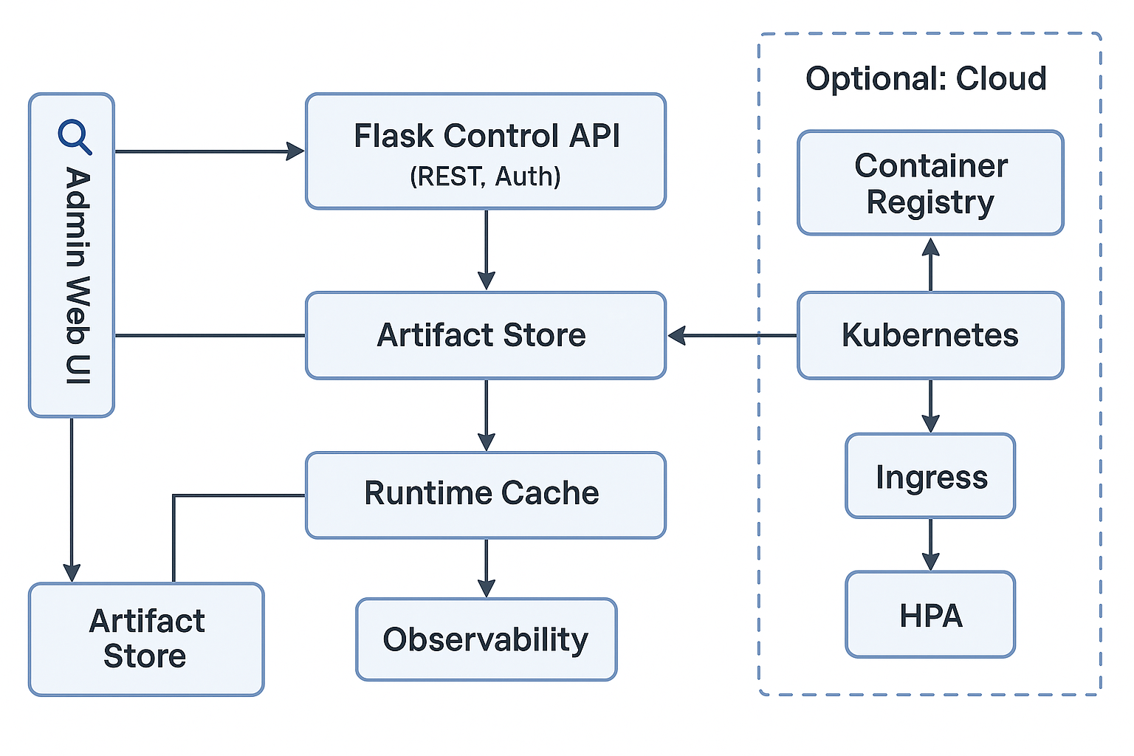
Flow summary: An admin uploads an artifact via the Control API/UI. The API writes the file to the Artifact Store, records metadata (name, version, hash, status) in the Model Registry, then optionally runs a quick validation (load + sample inference). When the admin activates a version, the Runtime Cache loads it into memory. Clients call /predict/<model>; the Prediction API resolves the active version (or a requested version), validates the JSON payload against the stored schema, executes inference through the runtime, and returns results along with correlation IDs. Metrics (request count, latency histograms, error codes) and structured logs are emitted on every request. In cloud mode, the Prediction API sits behind an ingress/gateway and scales horizontally; all other interactions remain the same.

DFD Level 0 (Context)
At Level 0, the platform is a single logical process—Model Deployment & Serving System—interacting with four external entities: Data Scientist/Admin (uploads/activations), Client Application (prediction requests), File System/Object Store (artifact persistence), and Monitoring Stack (metrics/log shipping). Inputs include Model Artifacts and Admin Commands; outputs are Prediction Responses, Metrics/Logs, and Registry Updates. The boundary shows that training datasets and CI/CD are out of scope; only already-trained artifacts cross into the system. Security (auth for admin routes) and basic validation (schema, size/time limits) occur at the boundary to protect internal components and maintain predictable performance.
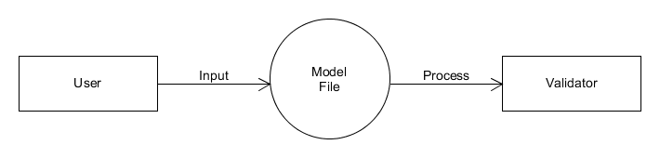
DFD Level 1 (Decomposition)
The Level 0 process decomposes into six sub-processes: (1) Upload Handler (receive file/metadata, compute hash, persist artifact), (2) Registry Manager (create/update model/version records, state transitions), (3) Validator (attempt load; optional sample inference; write status), (4) Activator (set active pointer; warm runtime cache), (5) Predictor (resolve version, validate payload, run inference, format result), and (6) Telemetry Emitter (emit metrics/logs with correlation IDs). Data stores are Artifact Store and Registry DB. Control flows: Upload → Validator → (success) Activator; prediction uses Predictor → Telemetry. Failures return structured errors without mutating active state.
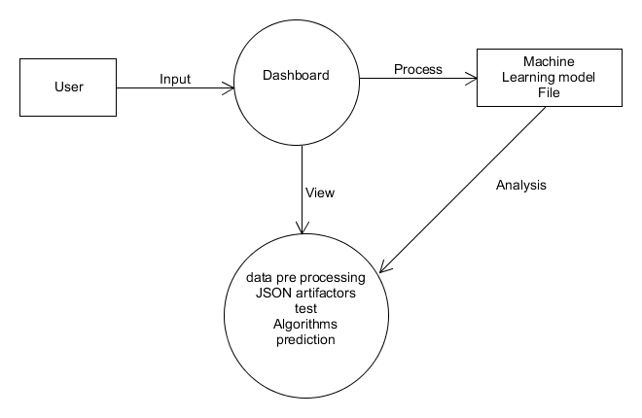

Activity Diagram
The activity begins with Receive Upload → Store Artifact → Write Registry Entry (uploaded) → Run Validation. On success, the admin may Activate Version; the system sets Active Pointer, Load to Runtime Cache, and marks state deployed. In parallel, Expose Prediction API remains live. For each request: Validate JSON Schema → Resolve Version → Run Inference → Build Response (predictions + latency + IDs) → Emit Metrics/Logs → Return 200. If validation or inference fails, Return 4xx/5xx and log context without altering active state. The loop continues, supporting further uploads, activations, and predictions continuously.
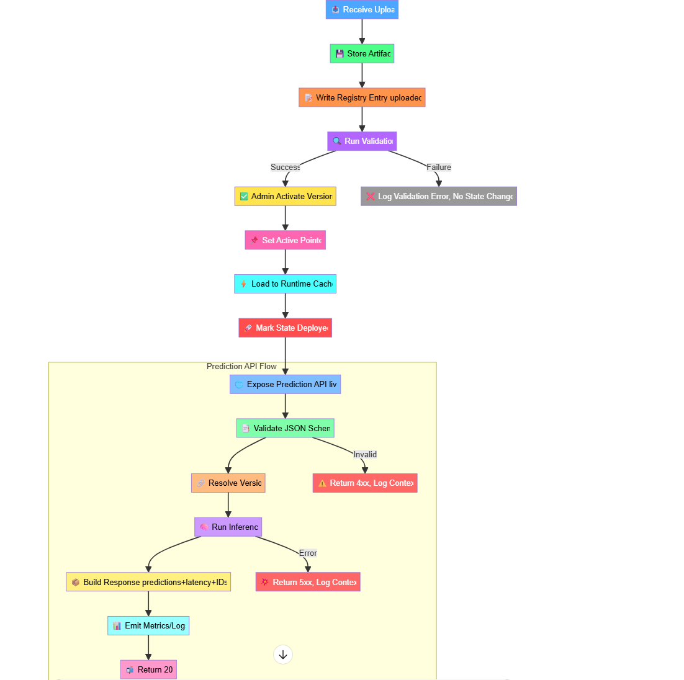
Use Case Diagram —
Actors: Admin (Data Scientist) and Client App.
Use Cases (Admin): Upload Model, List Models/Versions, Validate Artifact, Activate Version, Rollback, View Metrics/Logs.
Use Cases (Client): Request Prediction, Check Health.
Relationships: Activate Version «includes» Validate Artifact (or requires prior validation); Rollback «extends» Activate Version (switch active pointer to previous). Constraints: Admin routes require authentication; predictions enforce schema and request limits. Success guarantees: A valid activation immediately serves via /predict/<model>; rollbacks do not require re-upload. Non-goals: training, CI/CD, dataset management.

